Lab 15-1 | Examining Object Definitions
Objective: To practice examining object definitions in the repository. |  |  25-30 minutes

Instructions:
Siebel Tools is an integrated environment for configuring Siebel applications. You use Siebel Tools to modify standard Siebel object definitions and create new object definitions to meet your organization’s business requirements. Siebel Tools is a declarative configuration tool, not a programming environment. You use Siebel Tools to create and modify the object definitions (metadata) that define Siebel applications. You do not modify the source code or directly write SQL.

In this lab, you will explore some of the basic Siebel Tools navigation features.

1. In this step, you will start Siebel Tools then log in as SADMIN connecting to the Sample database.
- Double-click on the Siebel Tools shortcut on the desktop.
- In the login screen, enter the following:

Field | Value
User ID | SADMIN
Password | SADMIN
Connect to | Sample

The Object Explorer (OE) should be displayed. The Types tab in the OE should be selected by default. Some example object types are applets, views, business components, and tables. The Object Explorer (OE) displays the types, and the Object List Editor (OBLE), which is to the right of the OE, displays definitions for those types. Together, they provide a view into the objects and object definitions in the repository database tables.

Shown below are the Object Explorer and Object List Editor when Applet object type is selected.
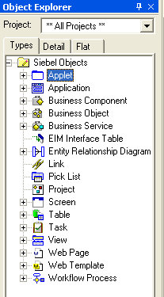

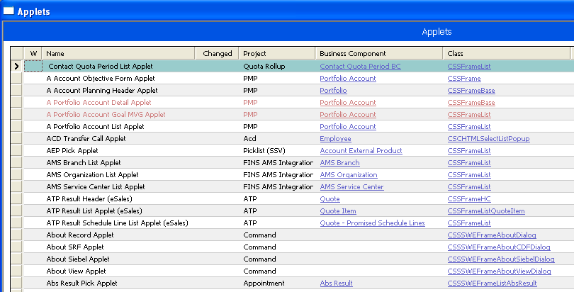

When you select an object type in the OE then create a new record in the OBLE, you are presented a template in the OBLE for the object type currently selected in the OE. Once you enter values into the template, you will have created a definition for the object. Hence, “object definition”.

- In this step, you will explore the record counter. Many objects in tools are displayed as individual records in the OBLE. The total number of records currently displayed can be determined by viewing the record counter, which is visible immediately underneath the OBLE.
  - Select Application in the OE. How many application object definitions are listed in the Object List Editor (OBLE)?

  - In cases where a large number of records are present, you can cause the record counter to numerate from the end of the list.
i. Select Table in the OE.
ii. Use the vertical scrollbar at the far right of the OBLE to navigate to the last record. To do so, select the slider control inside the vertical scrollbar and pull the slider all the way down to the bottom of the vertical scrollbar.
iii. Slowly scroll up.
iv. Observe the record counter behavior.

- In this step, you will learn how Tools indicates the active object definition.
  - Select Application in the OE.
  - Select the Siebel Universal Agent object definition in the OBLE by clicking the row tab to the left of the record. What visual cues indicate that a definition has been selected?

- In this step, you will explore child object types. Object definitions have hierarchical relationships called parent-child relationships. The Types tab in the OE shows the object hierarchy. Clicking the plus sign (+) to the left of an object type displays all the child object types of the top-level object type. Clicking the minus sign (–) to the left of an object type collapses all its child object types. By default, not all object types are visible in the Object Explorer.

Example: Expand an object type in the OE, such as Business Component, child object types should be seen similar to the following:

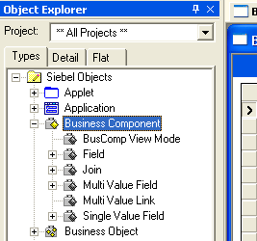

Parent-child relationships between these objects imply that the child object is in, or belongs to the parent object, but it does not imply inheritance among objects. The set of properties of a parent object is generally unrelated to the set of properties of a child object.

- Expand the Application object type.
- How many child object types are listed for the Application object type?

- In this step, you will query to display all the page tabs that are included in the Siebel Universal Agent application.
  - Select Application :: Siebel Universal Agent | Page Tab. This notation means to first select the Application object type in the OE, next select the Siebel Universal Agent record in the OBLE, and then select the Page Tab child object type in the OE.
  - Perform a null query to ensure that all the Page Tab child object definitions are listed.
    - From the application-level menu, select Query > New Query.
    - Select Query > Execute Query
    - Based on the number of child page tab object definitions displayed, what can you infer about the object definition’s relationship with the parent Page Tab object type?
      - There can be zero to many object definitions for an object type.
      - There can only be one object definition for a given object type.

- In this step, you will navigate to Screen :: Contacts Screen | Screen View. Then, you will use a wildcard to query similar items. A number of common operators are available, such as =, >, <, <>, LIKE, etc. You can also use AND, OR, and NOT to issue a compound query. By default, Siebel Tools queries are case sensitive. For more information, reference Using Siebel Tools.
  - Select Screen in the OE.
  - Click anywhere in the OBLE.
  - Click the New Query button.
  - Enter Accounts Screen in the name property.
  - Click the Execute Query button.
  - Expand the Screen Object Type in the OE.
  - Select Screen View in the OE. Your interface should look similar to this:

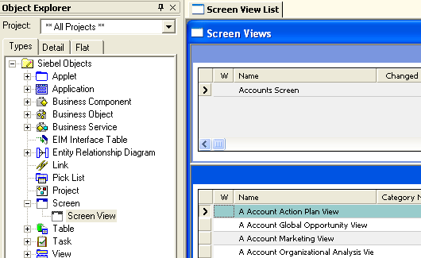

  - Query for all screen view object definitions named “Account Detail”. To run this query, bracket the string with asterisks. For example *Account Detail*.Your query should return 30 records.
  - Now use an operator in your query: *Account* AND *Detail*. Your query should return 34 records. AND returns all the records with name containing both “Account” and “Detail”.
  - Use the OR operator. Query *Account* OR *Detail*. Your query should return 226 records.
  - Query for an object definition that contains special characters.
    - Select Business Component in the OE.
    - In the Name property of the OBLE, query for 'Account (Contact Us)'. Ensure you bracket the query with single quotes.

- When working in Tools, it is often useful to display and reorder columns to only display properties you seek, or to move desired properties into the immediately viewable area of the OBLE.
  - Reorder columns to place the Sequence column next to the View column.
    - Right-click anywhere in the Screen Views window.
    - Select Columns Displayed.
    - Select Sequence in the Displayed columns dialogue box and use the arrows to move it to follow immediately after the View.
    - Click OK.
    - Observe the change in the OBLE. You should see the Sequence property immediately to the right of the View property. If necessary, use the OBLE’s horizontal scroll bar.

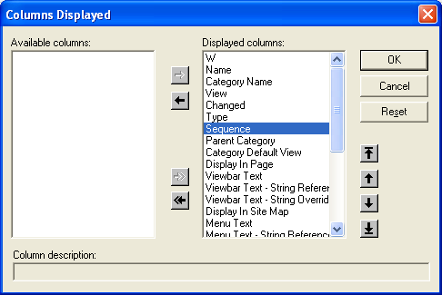

- In this step, you will use Siebel Tools hyperlinks to quickly navigate between related objects.
  - Select Screen :: Accounts Screen | Screen View :: Account Activity Plan
What is the value of the View property?

  - Drill down to the Account Activity Plan view by clicking the Account Activity Plan hyperlink.
  - Identify the value of the Business Object property. What is the value of the Business Object property?

  - Drill down on the Business Object property. Note that you have now navigated from the UI layer to the business layer via Hyperlinks.
  - Click the back arrow to return to Account Activity Plan view

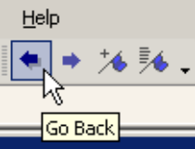

- In this step, you will use Flat tab to display object types (parent and child) in a single, alphabetically arranged list, without displaying the parent-child relationship. When Flat tab is used. If the object selected is the child in a parent/child relationship, additional parent information is included in the OBLE that is not present when the Type tab is used. If there are multiple parents that reference the same child, then the child is repeated in flat view for each parent that references it.

The Flat tab is particularly helpful in finding a child object with an unknown parent. For example, if you created a new field but do not remember what business component it is in, you can select the Field object type in the Flat tab and search the Name property for the field name in question.
- Select the Flat tab in the OE.
- Select the Screen View object type. When you use the Flat tab, you may notice a slight delay before the list of objects is displayed in the OBLE. This is due to that fact that all objects in the repository of the type you select, such as Screen View, are displayed.
- In the OBLE, query for the screen view object definition named Account Activity Plan View. What screen is its parent (look for the Parent Screen property)?

- Click on the Accounts Screen hyperlink in the Parent Screen property of the OBLE. What happens in the OE?

- What happens in the OBLE?

- Identify a Screen View that is referenced by multiple parent Screens.
    - Select the Screen View object type in the OE.
    - Query for a screen view named Account List. Your query should return 16 object definitions, each referenced by a different parent screen.
- Click the Types tab to restore the Object Explorer to the hierarchical display mode.

10. Leave Siebel Tools open for the next lab.
Solutions Lab 15-1 Examining Object Definitions

2.a. 71

3.b. An active record indicator appears at the far left, and the record is highlighted in color.

4.b 2, Page Tab and Screen Menu Item

5.b.iii. There can be zero to many object definitions for a given object type.

8.a Account Activity Plan

8.c. Account

9.c. Accounts Screen

9.d. The Screen object type is automatically selected.

9.e. The Accounts Screen object definition is displayed.

